

Practices for Secure Software Report

Table of Contents
Document Revision History 3
Client 3
Instructions 3
Developer 4
1. Algorithm Cipher 4
2. Certificate Generation 4
3. Deploy Cipher 4
4. Secure Communications 4
5. Secondary Testing 4
6. Functional Testing 4
7. Summary 4
8. Industry Standard Best Practices 4

Document Revision History

Version | Date | Author | Comments
1.0 | 10/22/2026 | Brandon Tomasello

Client



Instructions

Submit this completed practices for secure software report. Replace the bracketed text with the relevant information. You must document your process for writing secure communications and refactoring code that complies with software security testing protocols.

- Respond to the steps outlined below and include your findings.
- Respond using your own words. You may also choose to include images or supporting materials. If you include them, make certain to insert them in all the relevant locations in the document.
- Refer to the Project Two Guidelines and Rubric for more detailed instructions about each section of the template.

Developer
Brandon Tomasello

Algorithm Cipher

In the case of Artemis Financial, I recommend the utilization of AES-256-GCM as the encryption algorithm. Being that AES is a symmetric encryption algorithm; it is able to use the same key for both encryption and decryption. The 256-bit key provides a strong level of security while GCM offers authentication for if data has been altered in any way. This being the scenario, AES was established by NIST as an encryption standard in the year 2001 and is now widely used today.
Hash functions serve a separate function from encryption. In this scenario, SHA-256 is utilized as a checksum verification and as a result produces a 256-bit hash. Hashing is designed to function as a one way process rather than something that is able to be decrypted. Secure random number generation is also an essential factor. When creating cryptographic values, predictable values can weaken seemingly strong security. Java provides cryptographic functionality such as SecureRandom for this exact purpose.
AES is symmetric, while asymmetric encryption uses separate public and private keys. Asymmetric cryptography is especially useful in cases such as generating certificates and secure key exchange. Symmetric encryption is typically more efficient for the encryption of larger data. In the scenario of Artemis Financial, AES-256-GCM provides a strong modernized standard for the protection of sensitive information housed in a financial institution.

Certificate Generation

For Artemis Financial, I generated a self signed certificate using the Java Keytool. The certificate utilizes a 2048-bit RSA public key. It was exported as the artemis certificate .cer file and the information was then validated using Keytool.

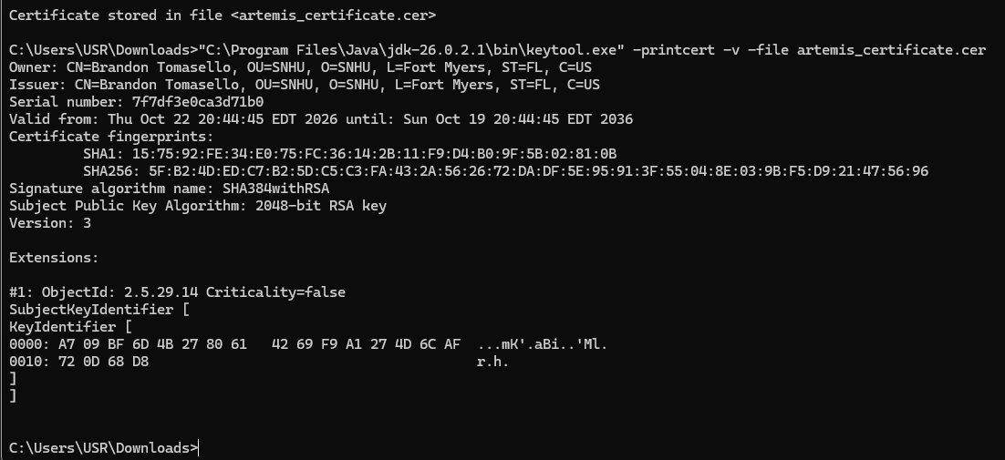

Deploy Cipher

SHA-256 checksum is generated from a unique string.
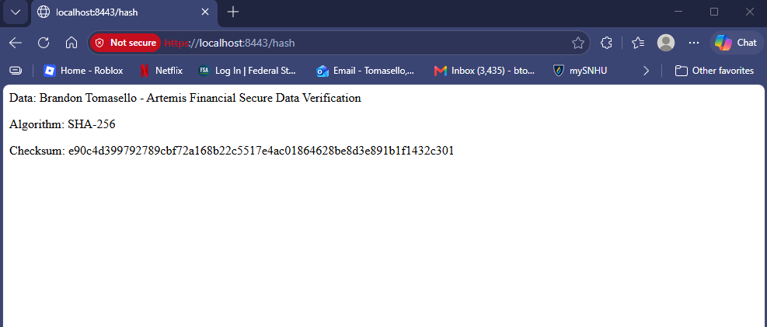

Secure Communications

For this step, secure communication was established through configuration of the HTTPS on port 8443. The application uses the generated PKCS12 keystore and self signed certificate. The checksum endpoint was also successfully accessed through the https://localhost:8443/hash.
EXPLANATION: While the application itself is indeed communicating through HTTPS, it is absolutely apparent that the page itself shows a “Not Secure” warning. It is to my understanding after researching that this is due to the certificate being generated as self-signed and is not trusted through any Certificate Authority. The certificate itself was also generated under my name “Brandon Tomasello” as opposed to the actual authorized local host. I believe that this did indeed create a validation issue due to the difference in host name. So this resulted in the “Not Secure” message when accessing a local host webpage. In a normal instance, a certificate issued by a trusted CA with proper host name would be implemented to satisfy the criteria. Carrying this out would result in the browser being able to properly validate the identity of the server.

Application accessed through HTTPS on localhost port.

Validation of self-signed certificate presented by the application. Shows the certificate identity and validity information.
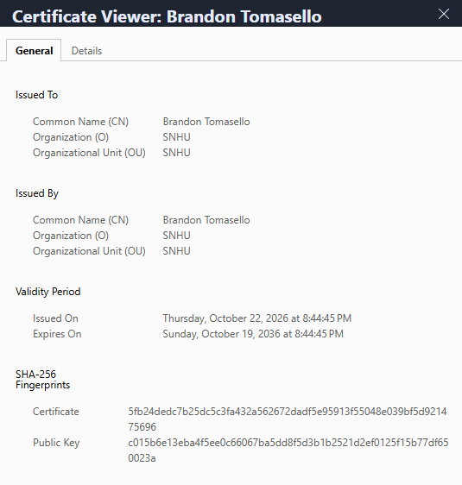

Secondary Testing

Secondary testing was conducted through the utilization of the OWASP Dependency Check. The final scan resulted in 49 dependencies with 28 of them being unique. There were a total of 14 vulnerable dependencies found in the check. The findings are from the dependencies associated with the original project files and not due to new implementations such as the checksum. These results indicate that the application needs to be reviewed, dependencies need to be updated, and dependency check needs to be run throughout further development.
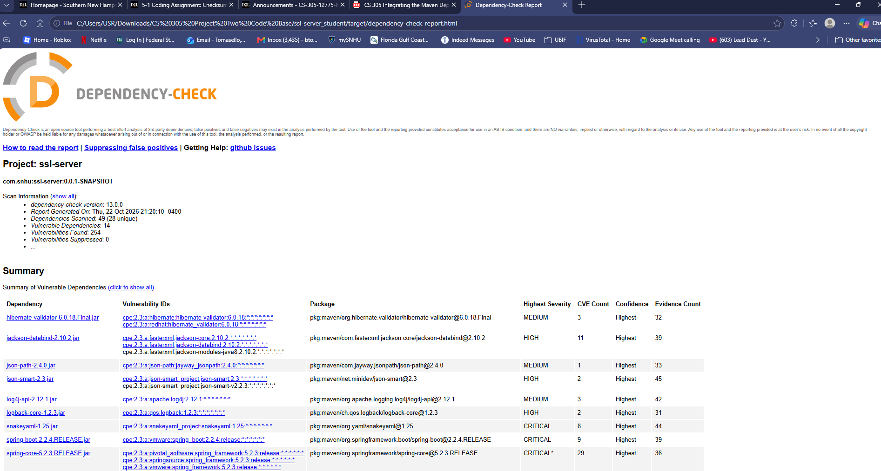

Functional Testing

Completed through manual review of the code and running application after security changes were implemented. Application successfully deployed on local port and SHA-256 checksum was generated without errors. Verified that SHA-256 and UTF-8 encoding were properly utilized.

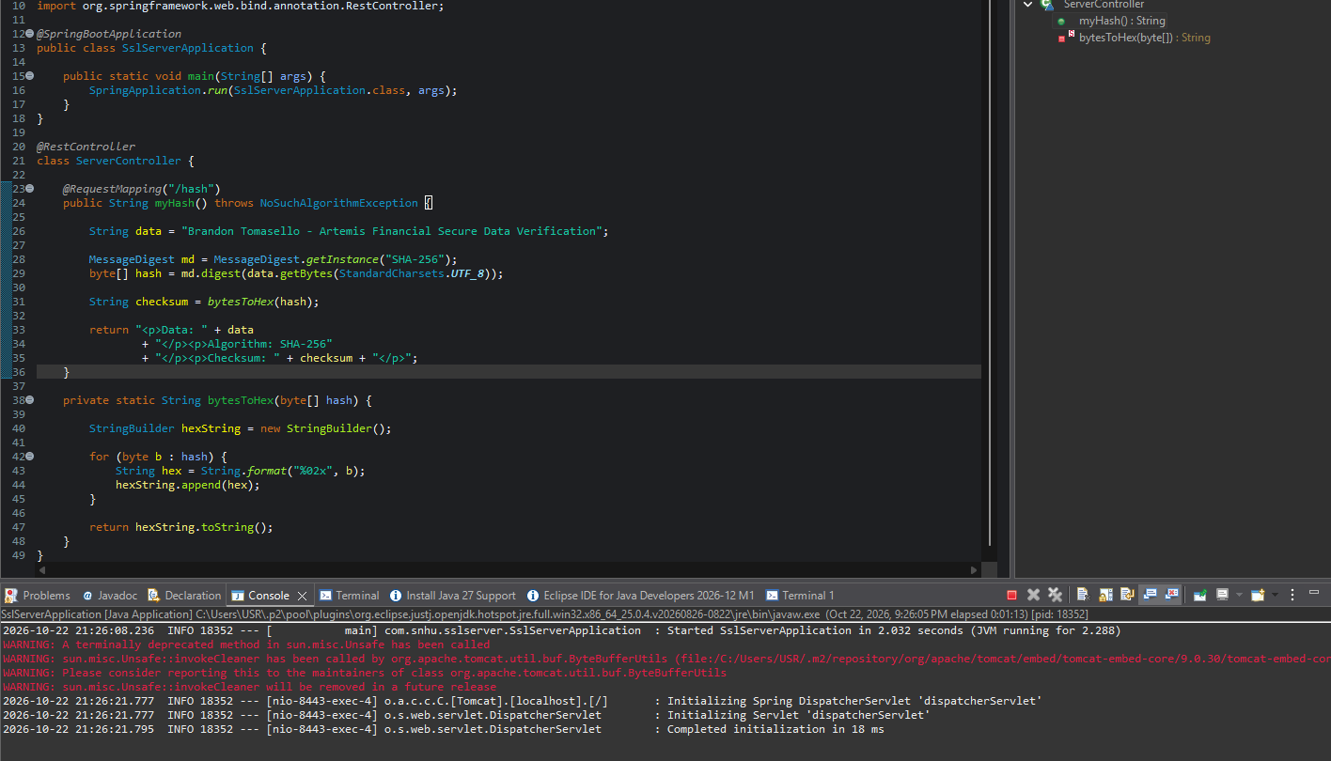

Summary

The security implementations for Artemis Financial were strictly focused on several key areas. After review of the Vulnerability Assessment Process Flow I strictly focused on cryptography, secure client/server communications, code quality, and security quality assurance testing. I implemented SHA-256 to provide the application with a checksum verification to maintain data integrity while using HTTPS and the generated certificate added security to client/server communications. The deployment of the OWASP Dependency Check tool was used to perform static testing and helped to identify known vulnerabilities within the dependencies found in the project. After this, functional testing was conducted to confirm that the “refactored” application executed without error following the changes being implemented.
These improvements demonstrated the importance of there being layers to security protocols. Rather than relying solely on a singular security measure, there are multiple factors implemented to various sections of the application. Hashing is used to verify data integrity while HTTPS protects data being transmitted, and certificates further add to that by supporting secure communication. Testing for vulnerabilities and such after increasing the overall security allows one to pinpoint focus on weak points and further aid in remedying security concerns.
Some additional improvements to the overall application would be updating vulnerable dependencies to current versions, storing configuration settings in a secure manner, using CA issued certificates, and implementing proper access controls within the company. These improvements would allow Artemis Financial to further upgrade their security while establishing a better system for future implementation.

Industry Standard Best Practices

Implementing industry standard security practices requires consistent monitoring and improvement throughout the development life cycle. Artemis Financial should conduct routine maintenance and updating of third party dependencies, regular vulnerability scans, maintain secure certificates, secure sensitive credentials, and enforce cryptographic standards. Their security team should also continue to conduct routine testing and implement changes as needed. As new vulnerabilities are discovered they must be easily identified and addressed before the application itself is deployed for public use.
Maintaining these practices secondarily adds value to the business model behind Artemis Financial. Offering security protocols such as this is another key factor to draw clients to their business. Aside from it of course being entirely necessary, they will be portrayed as a responsible, knowledgeable, and modern financial institution. Security should therefore remain an ongoing part of development that scales with the company rather than only being assessed when issues arise.

